PENNSYLVANIA DISTRICT KIWANIS INTERNATIONAL
CONVENTION BUSINESS SESSION MINUTES
1O4th DISTRICT CONVENTION
AUGUST 21, 2021

The business session of the 104th Pennsylvania District Convention was called to order at 2:00pm on August 21, 2021 in the Pennsylvania Ballroom of the Hilton Harrisburg Hotel in Harrisburg, PA.

Governor Don Smith presided.

The session opened with the Pledge of Allegiance and National Anthem and opening thought provided by Human and Spiritual Aims Chair Ann Graves

Governor Smith recognized those members who have achieved Legion of Honor Status. He, also, recognized all Kiwanians who have been in Kiwanis one year or less.

A memorial tribute to Kiwanians who have passed since August 1, 2020 was conducted.

Via video, Key Club Governor Preston Martz provided remarks.

Membership Chair Tiffany Callaio presented some membership awards for the 2020-21 year.

Counselling Kiwanis International Trustee Dan Leikvold brought greetings from Kiwanis International and provided remarks to the assembled delegation.

A Robert P. Connelly Award was presented to Kevin Conklin for his heroism in preventing a drowning. The award was presented by Allentown Northeast Club President Cathy Kane.

Credentials Committee Chair Karen Sears provided a report. There were 119 certified delegates and 13 certified delegates-at-large for a total of 132 delegates certified by the credentials committee. There were 112 of those delegates present at the session. Accordingly, a majority vote would be 57 and a two-thirds majority would be 75.
70 clubs were represented. The required quorum was 51 clubs.

A report was provided by District Executive Director/Secretary/Treasurer Kevin Thomas. A copy is included with these minutes.

Resolutions were presented by District Laws and Regulations Chair Jennifer Crowell. Those resolutions are Included with these minutes. They were adopted by proper motion, second and unanimous vote.

An amendment to the District Bylaws was considered and presented by Jennifer Crowell. A copy of the amendment is attached. The amendment was approved by unanimous vote.

The annual meeting of the Pennsylvania Kiwanis Foundation was conducted by Foundation President Jeff Rose. Election of Foundation Directors was conducted. Elected by the delegates were Sonia Glass of the Kiwanis Club of Lebanon and Christopher Hindman of the Kiwanis Club of Huntingdon.

A presentation was provided on the 2022 District Convention to be held in Erie, PA.

The election of the 2021-22 District Governor-elect was conducted. There was one declared candidate for the office; he was Mike Coolbaugh of the Kiwanis Clubs of Wyoming Area. The nomination of Mike Coolbaugh was done by Steve Harmanos of the Kiwanis Clubs of Wyoming Area. The second was done by Cathy Szymanski of the Kiwanis Club of Erie. Mike Coolbaugh addressed the assembled delegates. As there were no other declared candidates, Mike Coolbaugh was elected by unanimous ballot.

The election of the 2021-22 District Governor was conducted. Sarah Zulueta of the Kiwanis Club of The Main Line and University City and 2020-21 Governor-elect was the only declared candidate for the office. She was nominated by Jim Hanna of the Kiwanis Club of The Main Line and her nomination seconded by Tiffany Callaio of the Kiwanis Club of Wyoming Area. Sarah Zulueta was elected by unanimous ballot as Governor for 2021-22.

Announcements were provided by Executive Director Kevin Thomas.

With no other business to conduct, the session was adjourned.

Respectfully submitted,

Kevin E. Thomas
District Executive Director/Secretary/Treasurer
Executive Director Report – 2021 Convention
- The District ended the 2019-20 year with a net membership loss of 169. While by no means a victory, that loss was less than expected given the entire second half of the 2019-20 year was adversely affected by the Covid pandemic. As of October 1, 2020, District membership stood at 3,042 members. The District has not seen a membership gain since the 2005-06 administrative year.

- We lost 5 clubs in the 2019-20 year. These clubs were Summit, Ligonier Valley, Hazleton, Laflin and Council Rock. We did open one new club in the 2019-20 year, Media.

- For the 2020-21 year and as of July 31st, the District was showing a membership gain of 141 members. That is ahead of the pace at any time in the last five years and to some extent given the circumstances that is remarkable. The leading club gain is Erie in Division 1 with a gain of 24, followed by Fort LeBeouf which is, also, in Division 1 with a gain of 18. Several more clubs have double digit gains including the Kiwanis Club of Wilkinsburg in Division 6 which went from 3 members to 15 members. I must add, however, that based on history and current economic and social challenges, I would not expect the District to see a membership gain for the 2020-21 year.

- To date in this administrative year, the District has lost four clubs; those clubs were Millcreek Area, Titusville, New Castle and Valley Forge. We have not opened any new clubs. I would expect perhaps a few more clubs to surrender their charters. Perhaps we may open one or two new clubs before the end of this administrative year.

- Because of Covid-19 restrictions and for the safety of all members of the Kiwanis Family of organizations, the Key Club District Convention, Circle K District Convention, Key Leader and the Kiwanis Midyear were cancelled as live events and were held virtually. Fortunately because of strong hotel relationships and strong negotiating, we did not incur significant losses of any nature. Since we have cancelled these events for two consecutive years, it may be challenging to generate interest in them as live events. However, the better than anticipated attendance at this event is encouraging and I am hopeful that kind of interest extends to our Service Leadership Program events. And we must hope that we do not have to cancel any of these events for a third year.

- The virtual midyear conference ended up with an attendance of over 150 Kiwanians registered. Despite technical challenges, the evaluations were very strong. The financial risks of a virtual conference are minimal. Accordingly, your District Board voted to have the Midyear in 2022 as a virtual conference again with a date to be determined.

- In the 2019-20 year, the District saw a surplus of over $44,000. The District applied for and received a Payroll Protection Program loan of $13,900; that loan has been forgiven and does not need to be paid back. As well and if there is a silver lining to Covid, many of our expenses were below budget projection because of limited activity. We have eliminated any external debt and are debt free. Despite the challenges created by Covid-19 and barring an unexpected event, I would expect surplus for the 2020-21. We applied for and received a second Payroll Protection Loan and expect that to be fully forgiven as well. For 2021-22, I expect we can put together a budget that will allow us to focus on our priorities while continuing to strengthen the District’s financial position. However, I would be remiss to not point out that the uncertainties created by Covid-19 to our Circle K and Key Club programs represent a potential risk that could add to the challenges we face in the upcoming year. More on that in a moment.

- After 14 years in the same location, the District office will be moving from its present location on Linglestown Road outside of Harrisburg to Enola, Pennsylvania. We will be moving from an office of about 1,200 square feet to one of about 850 square feet. Primarily we are moving because the space we have now is being underutilized, we were storing stuff just because we could and not unimportantly, we save $5,500 a year. Between the move, digitizing and disposing of items and other related costs, most of the savings in the first year will be eaten up but we can expect to save over $11,000 in years two and three of the lease for our new space.

- As I have already reported and while over the last several years the District Boards have taken action that has significantly strengthened our financial position, the long-term trend is not sustainable for us if we can not reverse the long-term decline in membership across the District. If we do not eliminate membership losses and begin having membership gains, the District will be challenged to maintain operations.

- Last year I reported to you that the Pennsylvania District was one of 24 Districts not in good standing with Kiwanis International due to reporting requirements involving Key Club. I am pleased to tell you we have resolved all those issues and we are now back in good standing. We have additional work to do to fully merge Key Club financial records under the Kiwanis financial records but we are on track to do that and should have that complete by this time next year.

- While on Key Club and Circle K, I should tell you that without equivocation the challenges created by Covid-19 are the greatest challenges faced by either program in my 35-year tenure. The same would apply to Builders Club and K-Kids. With schools struggling to meet Covid-19 challenges, clubs and extra-curricular activities were taking a back seat except for sports. To give you an idea of the impact, Key Club membership fell by 50%, from about 64,000 members on March 31, 2020, to about 32,000 members on March 31, 2021. We are hopeful of a rebound in membership this coming year but should the current Covid surge affect school operations adversely again this year that may not happen and then we may well be faced with some difficult choices on the District level as it relates to these programs.

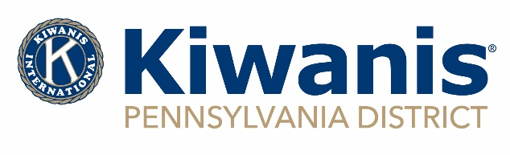

RESOLUTION
Whereas, the Pennsylvania District of Kiwanis International has enjoyed during the 2020-21 Administrative year, successes in many areas and have made progress in strengthening the District operations and the general strengthening of Kiwanis;
Whereas, without the devotion of Governor Don Smith, Immediate Past Governor Mike Haven, Governor-elect Sarah Zulueta, Executive Director Kevin E. Thomas, these successes would not have been possible; and
Whereas, the dedication of the District’s seven Trustees have provided great direction and insight to the District; and
Whereas, the dedication of the District’s Lt. Governors, who are the eyes, ears and spokespeople of the Governor in their respective Divisions, has been exemplary; and
Whereas, the service of the District Chairpersons has been supportive of the goals of this Administrative year, and
Whereas, the 2021 Host Committee has done an outstanding job under challenging conditions, and
Now, Therefore, be it resolved that the Pennsylvania District of Kiwanis International, meeting in Convention at Harrisburg, Commonwealth of Pennsylvania, on this 21st day of August, 2021, extends to the aforementioned individuals its sincerest thanks for their furthering of the Objects of Kiwanis International during the 2020-21 year Administrative year.
Donald “Don” Smith, Governor
Kevin E. Thomas, Executive Director

Adopted August 21, 2021 at the 104th Annual Convention

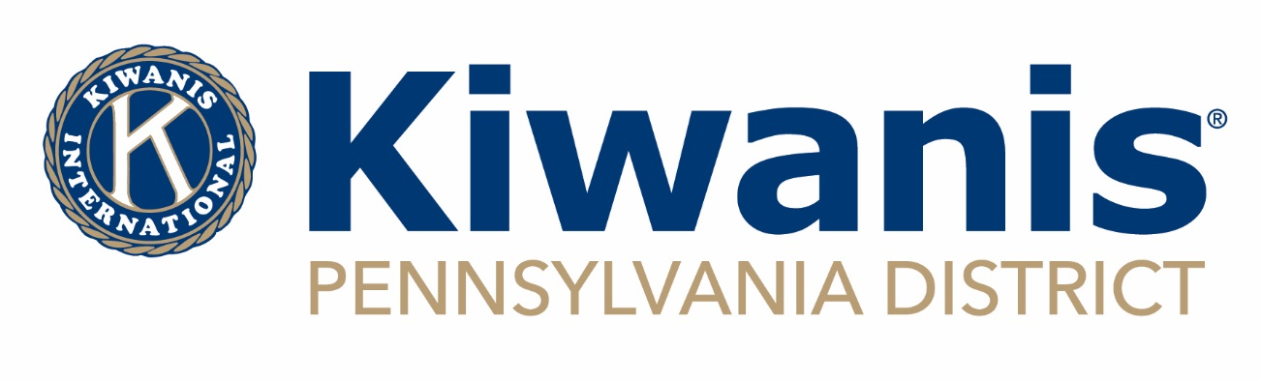
RESOLUTION
Whereas, the Pennsylvania District of Kiwanis International enjoyed the leadership and guidance of Willi Schaefer for many years; and
Whereas, Willi served Kiwanis and the District in many capacities including Club President, Lt. Governor, Chairman of several District committees including Circle Administrator, District Foundation Director and Governor in 1988-89; and
Whereas, Willi was an outstanding and loved professional, community leader, father and husband;
Now therefore, be it resolved that the Pennsylvania District of Kiwanis International, meeting in convention on August 21, 2021, at Harrisburg, Pennsylvania, wishes to express its heartfelt condolences to his family and that a copy of this resolution be transmitted to them.

Adopted by the delegates at the 104th Annual Pennsylvania District Convention

__________________________ __________________________
Donald “Don” Smith, Governor Kevin E. Thomas, Executive Director

Adopted August 21, 2021, at the 104th Annual Convention
District Bylaw Amendment

ARTICLE X, SECTION 2

PROPOSED BY: The Pennsylvania District Kiwanis International Board of Trustees

PURPOSE: To prorate District Dues for new new members on a monthly basis

CURRENT READING: ARTICLE X, SECTION 6
A fee for each new member shall be paid to the district equal to the amount of prorated district dues based on when the member joins the club, as shown below. Clubs are exempt from paying the district new member fee for persons who are former members of a Service Leadership Program (SLP).
October and November: $35.00
December and January: $30.00
February and March: $25.00
April and May: $20.00
June and July: $15.00
August and September: $10.00

PROPOSED CHANGES: ARTICLE X, SECTION 6
A fee for each new member shall be paid to the district equal to the amount of prorated district dues based on when the member joins the club, as shown below. Clubs are exempt from paying the district new member fee for persons who are former members of a Service Leadership Program (SLP).
October and November: $35.00
December and January: $30.00
February and March: $25.00
April and May: $20.00
June and July: $15.00
August and September: $10.00

Prorated district dues shall be charged for each new member of a club on the same prorated schedule used by Kiwanis International.

FINAL READING IF APPROVED, ARTICLE X, SECTION 6:
Prorated district dues shall be charged for each new member of a club on the same prorated schedule used by Kiwanis International.

